Change Log
Revision | Submission Date  (dd-mm-yyyy) | Affected Sections or Pages | Change Summary
Initial | 11-12-2017 | All | Initial issue of document.
V2 | 04-05-2018 | Sections 3 and 4 | Updated requirements based on reviewer comments

Table of Contents
1 Document Overview 3
1.1 Identification 3
1.2 Purpose 3
1.3 Overview 3
1.4 Terminology and Notation 3
1.5 References 3
2 Overall Description 4
2.1 Product perspective 4
2.2 Product Functions 4
2.3 User Characteristics 5
2.4 Operating Environment 5
2.5 Design and Implementation Constraints 5
2.6 Assumptions and Dependencies 5
3 Interface Requirements 5
3.1 Communications Interfaces 5
3.2 Hardware Interfaces 5
3.3 Software Interfaces 5
3.4 User Interfaces 6
4 Functional Requirements 7
5 Performance and Reliability Requirements 9
6 Safety Requirements 9
7 Security Requirements 9
8 Adaptability Requirements 9
9 Other Requirements 9
A. Acronyms and Abbreviations 10

Document Overview

Identification
Property | Value
Element | IDS
Program Set | Geometry Streaming Server
Version | 1.0

Purpose
The purpose of this document is to identify the software requirements for the Geometry Streaming Server (GSS) maintained under the Advanced Multi-Mission Operations System (AMMOS). Rationales for the requirements are also identified.

Overview
The Geometry Streaming Server (GSS) is an assembly under the Instrument Data System (IDS) subsystem of MGSS which provides tools and services in the area of instrument data processing. The purpose of GSS is to support the distribution and display of large 3D datasets. Specifically, GSS is a web service that accepts triangulated meshes as input and reprocesses them into a set of tiles optimized for real-time streaming. This service enables frontend display tools to interactively download and display only the portion a mesh required to fill a user’s current field of view, allowing large meshes to be displayed efficiently.

Terminology and Notation
This document uses standard terminology and notation.

Some requirements have enumerated subcomponents. For example, requirement GSS-01 has (a), (b), and (c) components. Each of these components should be treated as individual requirements and referenced as GSS-01.a, GSS-01.b, and GSS-01.c respectively.

See Appendix A for acronyms.

References
Table 1: Applicable JPL Rules documents
Title | DocID
Software Development, Rev 9 | 57653
Table 2: Applicable MGSS documents
Title | Document Number
AMMOS Technical Standards Profile, Rev A | DOC-001101
MGSS Implementation and Maintenance Task Requirements, Rev B | DOC-001455

Overall Description

Product perspective
The Geometry Streaming Server (GSS) provides a standards-based mechanism for streaming large 3D datasets for real-time rendering. This is a new, self-contained product that enables models to be pre-processed and hosted in a way that is optimized to minimize data transfer and latency for clients. The main purpose is to support a mission operations environment by enabling web-based tools and other thin clients to easily display 3D models that would otherwise be too large to download and render in their entirety.
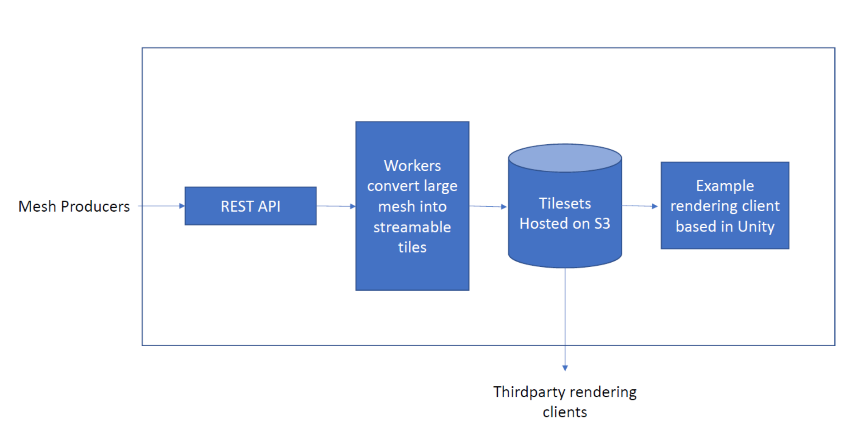
Figure 2.1.1: Generalized work flow showing the external interfaces that allow mesh producers to upload new models and that allow mesh consumers to download and display processed models. Included with the system is a reference implementation of a client built on the Unity game engine. Elements contained within the outer bounding box will be developed as part of the Geometry Streaming Server.

Product Functions
The Geometry Streaming Server has the following functions:
- Allow new models to be uploaded via a REST API
- Maintain a list of uploaded models
- Process models into a set of tiles at multiple levels of detail
- Store models in 3D Tile format and make them available via the web

User Characteristics
We identify two user classes:
- Mesh Producer: A producer is a user that generates new 3D data and wants to make it available for others. For example, a mesh producer might be a pipeline that produces 3D models from stereo cameras on board a surface vehicle.
- Mesh Consumers: A consumer is a tool that needs to be able to display portions of a 3D model and stream in additional data as the virtual camera moves. For example, a mesh consumer might be a tool that enables scientists to see models in a web page.

Operating Environment
The server will run on the Amazon Web Services (AWS) Cloud infrastructure utilizing services such as S3, SQS, Lambda, DynamoDB, Elastic Beanstalk, EC2, and Autoscale Groups. The EC2 instances will utilize the standard Windows Server 2016 image (or newer), although the software is compatible with other versions of windows as well.

Design and Implementation Constraints
There are no specific design and implementation constraints at this time.

Assumptions and Dependencies
We depend on the continued existence of the common AWS services specified in 2.4. However, the software is architected to support migration to alternate but similar cloud services in the future if necessary.

Interface Requirements

Communications Interfaces
Access to the REST interface for mesh producers to upload datasets will be accessed over HTTPS and secured via an API token, (Single Sign-On) SSO, or similar technology. By design, access for mesh consumers will be unsecured except by the standard access controls allowed by S3 when configured as an HTTP or HTTPS server. The server will use the 3D Tiles, glTF, and JSON specifications for storing models for streaming. The server will accept models uploaded in OBJ and PLY format.

Hardware Interfaces
There are no specific hardware interfaces; this is a software only implementation.

Software Interfaces

The server will expose a simple REST service for uploading new datasets and managing existing datasets. This API will allow users or other software applications to define new datasets and upload 3D models and textures associated with those datasets. The interface will also support querying status and metadata from existing datasets as well as deletion. Mesh producers will use this interface to upload new datasets. Mesh consumers can use this interface to discover what datasets are available.
GSS datasets are made available to rendering clients as static files through a standard HTTPS interface. Datasets are stored in a self-describing file format called 3D Tiles which allows clients determine what files they need to download at runtime.
ID | Requirement Statement | Rationale | Notes | Verification Method | Requester
GSS-01 | GSS shall accept triangular input meshes in:  - OBJ Format  - PLY ASCII Format  - PLY Binary Format | Allow users to upload meshes to tile. | NA | Test | Baseline
GSS-02 | GSS shall accept input textures for meshes in:  - JPG (8 bit)  - PNG (8 bit)  - TIFF (8 bit)  - TIFF (16 bit) | Allow users to upload textures to tile with meshes. | NA | Test | Baseline
GSS-03 | GSS shall accept input images with the following number of bands:  - 1 banded grayscale  - 3 banded color | Allow black and white as well as color images | NA | Test | Baseline
GSS-04 | GSS shall accept input datasets that are uploaded as single large mesh and image. | Allow users to upload datasets as a single part mesh. | NA | Test | Baseline
GSS-05 | GSS shall accept input datasets that are uploaded as a set of mesh and image pairs representing “leaf” tiles. | Allow users to upload large datasets as a collection of smaller files. | NA | TEST | Baseline
GSS-06 | GSS shall export tiles in the following formats:  - glTF  - OBJ  - TIFF | Allows export of individual tiles in a standards based web-friendly format. | NA | Test | Baseline
GSS-07 | GSS shall support exporting glTF image buffers with the following encodings:  - JPG  - PNG | Allows export tiles to use lossless or lossey (smaller but lower quality) texture compression | NA | Test | Baseline
GSS-08 | GSS shall export processed datasets using JSON based “3D Tiles” format. | Allows export of entire dataset comprised of multiple glTF tiles. | NA | Test | Baseline
GSS-09 | GSS shall provide a REST service for managing data products including functions to:  - UPLOAD  - LIST  - DELETE | Allows mesh producers to create and manage datasets. | NA | Test | Baseline

User Interfaces
The main user interface will be provided by the reference rendering client implementation. The reference client will support displaying a 3D model to the user and will have controls to translate and rotate the camera view. As the camera moves, new model data will be dynamically requested and displayed to ensure the users sees the highest resolution data appropriate to their viewpoint. Minimal GUI controls will be provided as the reference implementation is meant to server as an example or starting point for tool developers who want to implement a client or integrate the reference implementation into their application. The reference rendering client will be released as open source software.
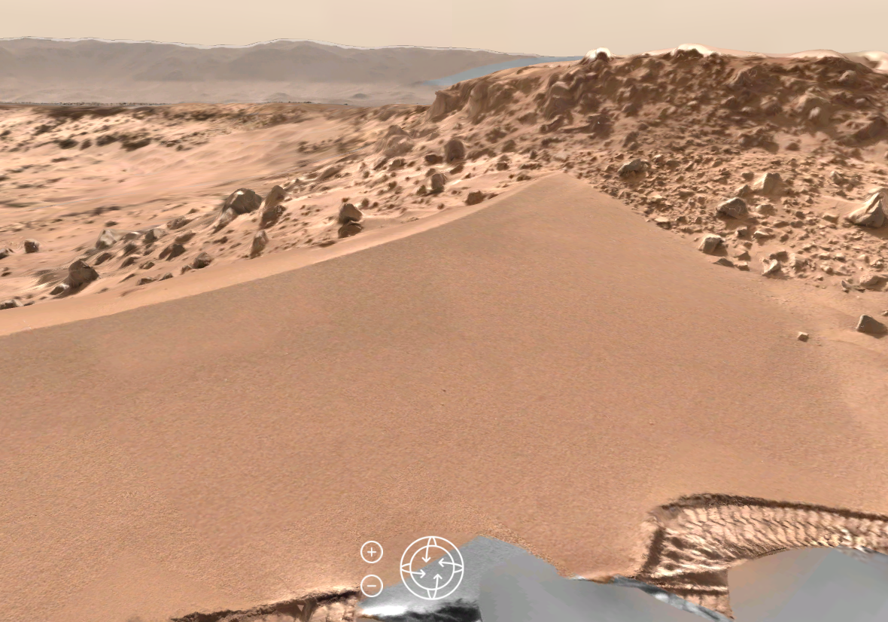

Figure 3.4.1: Example user interface with rotate and zoom controls provided with the reference client implementation.

Functional Requirements

ID | Requirement Statement | Rationale | Notes | Verification Method | Requester
GSS-10 | GSS shall support input meshes of at least:  - 2 million triangles  - Textures up to a resolution of 16k x 16k. | Allows upload of large meshes and textures. | NA | Test | Baseline
GSS-11 | GSS shall support export of meshes of at least:  - 250k triangles  - Texture resolution up to 8k x 8k. | Allows export of large meshes and textures. | NA | Test | Baseline
GSS-12 | GSS shall support meshes with the following per-vertex attributes:  - Position  - UV  - Normal  - Color | Support for the most common mesh attributes. | NA | Test | Baseline
GSS-13 | GSS shall provide a reference rendering client capable of:  - Rendering at 30 FPS  - Rotation  - Translation | Allows users to visualize exported datasets. | NA | Test | Baseline
GSS-14 | GSS shall support secure connections using the Transport Layer Security (TLS) V1.2 or greater. | Provides secure access to REST service. | NA | Test | Baseline
GSS-15 | GSS shall use the Advanced Encryption Standard (AES) 128-bit (or greater) keys, or Triple-DES (3DES) ciphers for the encryption of the TLS connections to and within GSS. | The use of AES or 3DES is required by JPL IT security requirements. | NA | Test | Baseline
GSS-16 | GSS shall support streaming exported tilesets to 500 (or greater) simultaneous users. | Server should be saleable to support serving data to many users at once. | NA | Test | Baseline
GSS-17 | GSS shall subdivide input meshes into a quadtree of leaf tiles. | Allows large input meshes to be cut up into smaller pieces for streaming. | NA | Test | Baseline
GSS-18 | GSS shall generate output tiles at multiple levels of detail. | Enables datasets to be streamed over a network efficiently and incrementally. | NA | Test | Baseline

Performance and Reliability Requirements
There are no specific performance or reliability requirements; missions may define their own, e.g. products available in web tools within N minutes of downlink. It is desirable, however, that mesh processing be as performant and parallel as practical to reduce the latency between upload and tileset availability to clients.

Safety Requirements
GSS contains no instrument or spacecraft commands and concentrates specifically on model processing and visualization, thereby no safety requirements are defined.

Security Requirements
GSS has no special security requirements except those imposed by a designated mission, but will at the minimum provide a secure connection, as outlined in requirement GSS-13 and GSS-14.

Adaptability Requirements
There are no adaptability requirements at this time.

Other Requirements
There are no other requirements at this time.

- Acronyms and Abbreviations
3D | Three Dimensional
3DES | Triple Data Encryption Standard algorithm
AES | Advanced Encryption Standard
AMMOS | Advance Multi-Mission Operations System
API | Application Programming Interface
ASCII | American Standard Code for Information Interchange
AWS | Amazon Web Service
EC2 | Elastic Compute Cloud
FPS | Frames Per Second
GDAL | Geospatial Data Abstraction Library
glTF | GL (as in OpenGL: Open Graphics Library) Transmission Format
GSS | Geometry Streaming Server
GUI | Graphical User Interface
HTTP | Hypertext Transfer Protocol
HTTPS | Hypertext Transfer Protocol Secure
IDS | Instrument Data Systems
JPG | JPEG: Joint Pictures Experts Group
JSON | Javascript Object Notation
MGSS | Multimission Ground Systems and Services
OBJ | Geometry definition file format. Simple data-format that represents 3D geometry
PLY | Polygon file format.
PNG | Portable Network Graphics
REST | Representational State Transfer
S3 | Simple Storage Service
SDK | Software Development Kit
SQS | Simple Queue Service
SSO | Single Sign-On
TIFF | Tagged Image File Format
TLS | Transport Layer Security
UV | “U” and “V” denote the axes of the two dimensional texture.

